Student Name: Xianglong Lin Student Number: 45791439 Team Name: H2OMG
Week: _7_
Title: Design Exhibit of Iteration 1
Description:
In the 7th week of Design Exhibit of Iteration 1, our team worked together to present our water resource project profile, prototype design map, interview transcripts, affinity diagram, concept, storyboards, low-fidelity prototype, and hardware dynamic of physical interactions. I mainly explained Storyboard 1 & 2, that explained how our system helps target users solve the problem of water waste. In Storyboard 1, I described how a father used our system to discover excessive water usage in a malfunctioning sprinkler system in the garden. While Storyboard 2 demonstrated how a family could use our system to monitor the duration of shower water usage and obtain relevant solution suggestions through the app. This first Design Exhibit not only presented our specific interaction methods of hardware and real-time water monitoring, but also provided valuable feedback and suggestions from the tutors on how to improve dynamic functions and optimise the user interface in the next iteration stage.
Visual Evidence:
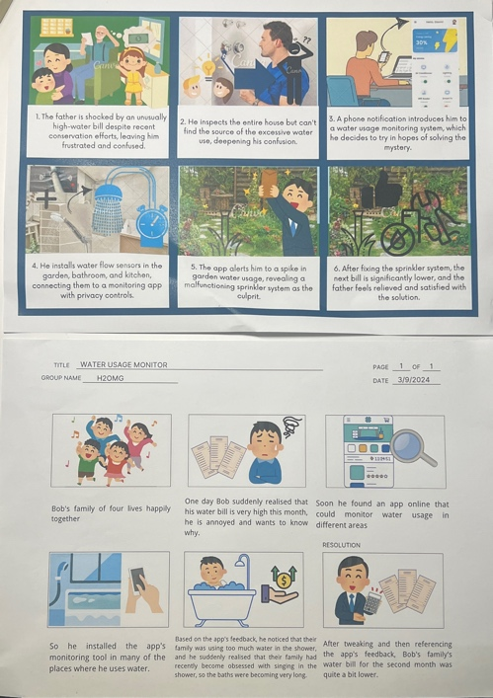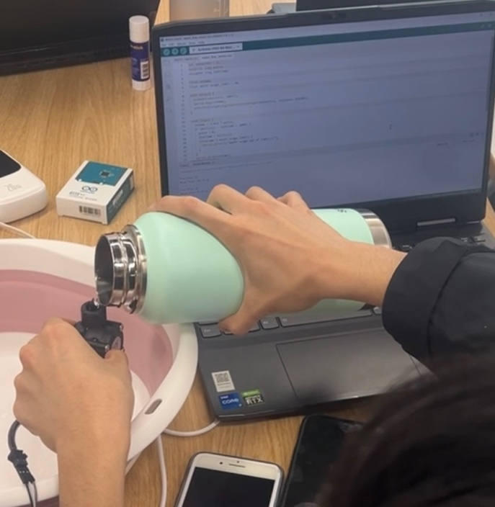
Statement on Learning:
The storyboards of this Design Exhibit made me deeply understand that it is necessary and important but also challenging to transform complex and professional digital technology solutions into a target form that is easy for target users to understand and feasible to operate. Although our Arduino had now achieved the ability to detect and calculate the amount of water flowing through the device within 10 seconds, it is worth considering how to convey this data in a form that users prefer rather than simply presenting it as data at this stage. For example, this requires us to try to design and create app notifications and reminder functions that are based on the data values of water flow, such as shortening shower time and repairing water leaks mentioned in the storyboards. Meanwhile, this made us realise the importance of simplifying technical explanations and how to operate and implement them, which would be particularly helpful for non-technical users or edge users. In the next iteration, we will develop the low-fidelity prototype into a high-fidelity prototype and start developing the front-end pages in succession. We will also conduct user tests to improve the clarity and usability of our water resource project as expected by users.

